WHAT DO YOU LIKE WATCHING ON TV?
Exercise 1 – Poslušaj posnetek in označi pravilni kvadratek.
JULIET FRED
+ | - |  | + | -
 |  | cartoons
 |  | detective films
 |  | nature programmes
 |  | sports programmes
 |  | science fiction films
 |  | romantic films

ANGELA FRANK
+ | - |  | + | -
 |  | cartoons
 |  | detective films
 |  | nature programmes
 |  | sports programmes
 |  | science fiction films
 |  | romantic films

Exercise 2 - Napiši, kaj otroci radi gledajo in česa ne.
Juliet likes _________________ and _____________________________. She doesn't like _________________________________________.
Fred likes __________________________________ and ____________________________________. He doesn't like _______________________________.
Angela likes _________________________________ and ___________________________________. She doesn't like ____________________.
Frank likes _______________________, ____________________________________________ and ___________________________________. He doesn't like ______________________________ and ________________________________.
Exercise 3 - Vprašaj svoje družinske člane in uporabi sledeča vprašanja:
- What do you like watching?
- What don’t you like watching?
- What do you often/sometimes/never watch?
 |  |  |  | 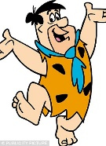 |  |  |  |  |  |  |  |  | 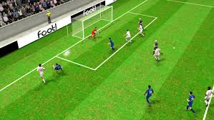
NAME | OFTEN | SOMETIMES  SSESES | NEVER | OFTEN | SOMETIMES | NEVER | OFTEN | SOMETIMES | NEVER | OFTEN | SOMETIMES | NEVER | OFTEN | SOMETIMES | NEVER | OFTEN | SOMETIMES | NEVER

Exercise 4 – Napiši stavke za 2 družinska člana.

- My _________________________ often watches ________________________, she/he sometimes watches ____________________________, but she/he never watches ____________________________.

- My _________________________ often watches ________________________, she/he sometimes watches ____________________________, but she/he never watches ____________________________.

