What do you do in your free time or at the weekends?
- Match – poveži
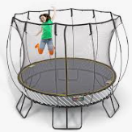 | 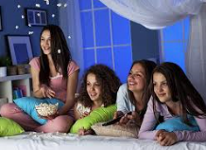 | 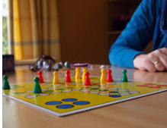 | 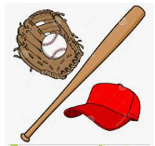 | 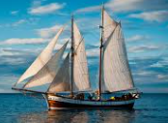
go sailing | play board games | go on a trampoline | have a sleepover | play baseball

- Listening: https://www.youtube.com/watch?v=piwlRwEdhw8
Poveži aktivnosti in imena otrok. V prazne kvadratke vpiši črke ustrezne aktivnosti.
- Thomas |  | - play in the garden, go on a trampoline
- Anita |  | - sleepovers and play board games
- Harriet |  | - making comics, going on PlayStation
- Luke |  | - tennis and stuff
- Grace |  | - go sailing and reading
- Holly |  | - play football
- Jine |  | - watching TV and playing on a trampoline
- Tara |  | - getting my friends on sleepovers
- Uma |  | - go on the computer
- Emma |  | - playing baseball
- Jalib |  | - shopping and swimming

- Work with mum, dad or siblings: Ask and answer.
Delo v družini: Vprašaj in odgovori.
Ask (vprašaj): | My family member: | His/her answer:
What do you like doing at weekends?
- Writing
- On Fridays I like ________________________________________________________
- On Saturdays I like _____________________________________________________
- On Sundays I like ______________________________________________________

