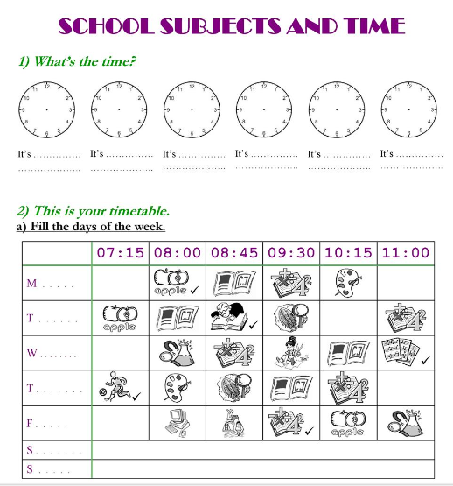
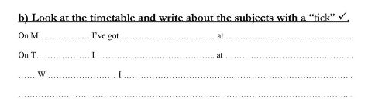

3. Poišči 10 šolskih predmetov.
E | N | G | L | I | S | H | I | A | F
F | R | E | M | U | S | I | C | R | P
R | E | R | A | S | B | U | T | T | E
E | H | M | T | A | S | B | G | I | Z
N | B | A | H | I | S | T | O | R | Y
C | W | N | S | C | I | E | N | C | E
H | B | I | O | L | O | G | Y | B | N

4. What lessons do you need these things?
Za katere šolske predmete potrebuješ naslednje stvari?
1. a ruler  a pencil  a calculator | 2. a map  a globe  minerals
3. a dictionary  a student's book  a notebook | 4. a piano  a drum  a flute
5. trainers  a ball  a T-shirt | 6. a brush  some paint  drawing paper
7. a computer  a keyboard  a mouse | 8. a skeleton  an anatomy atlas  a microscope

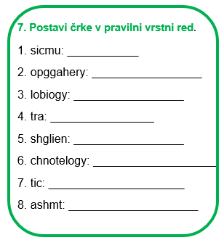
6. Kateri predmeti so?
1. In this lesson, you study science and ideas about how things work - _____________________
2. The study of life of people, animals and plants - _________________________________
3. The study of how to make beautiful things, like paintings and drawings - __________________________
4. The study of numbers, measurements and shapes - ___________________________________
5. The study of things that happened in the past - ___________________________________
6. In this lesson, you sing or play a musical instrument - __________________________________
7. In this lesson, you speak English and listen to people speaking in English - _________________________
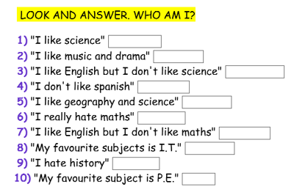
8A. Dopolni stavke glede na sličice
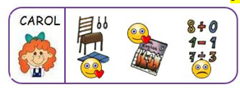 | My name ___________ Carol.  I ____________ maths.  I ____________ English.  I really ____________ P.E.
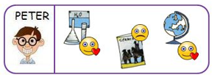 | I ____________ Peter.  I _________ geography, but I ________________ Spanish.  I really _______________ science too.
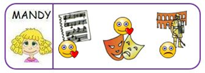 | My name ___________ Mandy.  I ____________ drama and music.  I __________________ history.
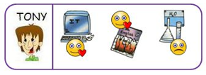 | I ___________ Tony.  I ____________ I.C.T but I ________________science.  I also _____________ English.

