Ime in priimek: \_\_\_\_\_\_\_\_\_\_\_\_\_\_\_\_\_\_\_\_\_ Točke: \_\_\_\_\_/53

Razred:\_\_\_\_\_\_\_\_\_\_\_\_ Odstotki: \_\_\_\_\_\_\_\_\_

Datum: \_\_\_\_\_\_\_\_\_\_\_

**PREVERJANJE 2 5. RAZRED**

1. **SLUŠNA NALOGA**

[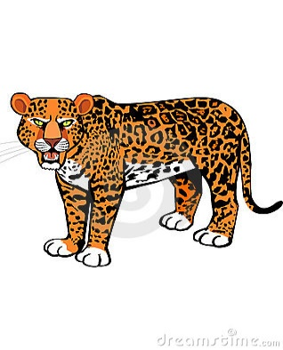](http://www.google.si/url?sa=i&rct=j&q=&esrc=s&source=images&cd=&cad=rja&uact=8&ved=0ahUKEwiO6pH3o6LLAhVC2hoKHWe-CToQjRwIBw&url=http://www.dreamstime.com/stock-illustration-hungry-leopard-cartoon-vector-illustration-image44389224&bvm=bv.115339255,d.ZWU&psig=AFQjCNENwwUmC7wKJ05GU4zMbHcDB0DtBg&ust=1457017627192483)

**Poslušaj posnetke in označi stavke z YES ali NO. \_\_\_/7**

[](http://www.google.si/url?sa=i&rct=j&q=&esrc=s&source=images&cd=&cad=rja&uact=8&ved=0ahUKEwjn-YvqpKLLAhXGChoKHU3zB0AQjRwIBw&url=http://kidungdraw.cf/cartoon/cartoon-lion-pictures.html&psig=AFQjCNH8DadV6rtJE17TwAqiUDXQuNOv3w&ust=1457017910063911)

|  |  |
| --- | --- |
| 1. Leopard is a big cat. | YES |
| 1. Leopards can’t swim. | NO |
| 1. Leopards live in the bush or in the forest. | YES |
| 1. Lions live in groups of 10 to 20 | YES |
| 1. Lions eat grass. | NO |
| 1. Lions are very lazy. | YES |
| 1. They sleep only 5 hours a day. | NO |

1. **FOOD \_\_\_/6**

|  |  |  |  |  |  |
| --- | --- | --- | --- | --- | --- |
| **name** | √ | **x** | **name** | **√** | **x** |
| **Jane** |  | [popcorn](http://esladventures.files.wordpress.com/2007/10/popcorn.gif) | **Paula** |  | [1](http://images.google.si/imgres?imgurl=http://www.l-m.si/upload/fotogalerija/v/1.1.1.5-alp-mleko-3.5.-0.5.jpg&imgrefurl=http://www.l-m.si/medijsko_sredisce/izdelki&h=400&w=400&sz=39&hl=sl&start=3&tbnid=6tDE9GYDxguPLM:&tbnh=124&tbnw=124&prev=/images?q=mleko&gbv=2&hl=sl) |
| **Amanda** |  |  | **Simon** | [milka_winterdreams3](http://images.google.si/imgres?imgurl=http://www.alertmedia.pl/img/pressroom/kraft_swieta/milka_winterdreams3.jpg&imgrefurl=http://matejaurajnar.blogspot.com/2007_12_01_archive.html&h=827&w=1713&sz=286&hl=sl&start=89&tbnid=r1b5fc3VthMs7M:&tbnh=72&tbnw=150&prev=/images?q=%C4%8Dokolada&start=72&gbv=2&ndsp=18&hl=sl&sa=N) | [jalbocna-baterija-2](http://images.google.si/imgres?imgurl=http://junior.si/images/uploads/eksperimentalnica/jalbocna-baterija-2.jpg&imgrefurl=http://junior.si/eksperimentalnica/arhiv/jabolchna_baterija/&h=230&w=230&sz=29&hl=sl&start=9&tbnid=maCWx_sa-IAN_M:&tbnh=108&tbnw=108&prev=/images?q=jabolko&gbv=2&hl=sl) |

1. **Odgovori na naslednja vprašanja s kratkimi odgovori.**

Does Jane like popcorn? No, she doesn’t.

Does Paula like lemonade? Yes, she does.

Does Amanda like fish? No, she doesn’t.

Does Simon like apples? No, he doesn’t.

1. **Napiši stavke za ostalo hrano, ki še ni bila omenjena v zgornjih vprašanjih in uporabi *likes* in *doesn’t like*.**

Jane likes eggs.

Paula doesn’t like milk.

Amanda likes sandwiches.

Simon likes chocholate.

1. **ŠTEVILA DO 100 – Na črte zapiši ustrezne besede za števila do 100. \_\_/10**

|  |  |  |  |
| --- | --- | --- | --- |
| 18 | eighteen | 53 | fifty-three |
| 12 | twelve | 77 | seventy-seven |
| 34 | thirty-four | 100 | (one) hundred |
| 69 | sixty-nine | 95 | ninety-five |
| 42 | forty-two (NE FOURTY!) | 81 | eighty-one |

1. **What's the time? Koliko je ura? Na črto s celim stavkom napiši koliko je ura. \_\_\_/5**

**V treh primerih uporabi naslednje fraze:**

**half past o’clock**

1. 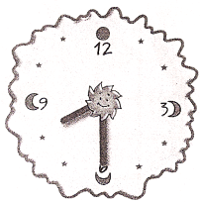 2.  3. 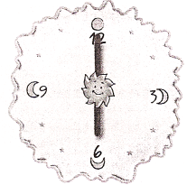 4.  5. 

|  |  |
| --- | --- |
| 1. It’s hald past eight. | 2. It’s half past eleven. |
| 3.It’s six o’clock. | 4.It’s one o’clock. |
| 5.It’s half past four. | |

1. **Pobarvaj sliko in opiši žival. \_\_/6**

**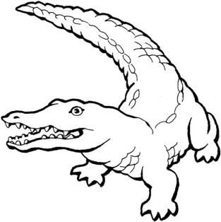 This is a crocodile. It is green.**

**It has got sharp teeth/scales/four legs/… and a long tail.**

**It eats other animals/meat/fish... It lives in the jungle/Africa/water….**

**It can swim/bite/roar….**

1. **Tvori vprašanja o spodnji živali. Uporabi besede v okvirčku. Nekaj besed je preveč.**

Potem na vprašanja odgovori. **\_\_\_/6**

run live has two wings have grass fly brown worms

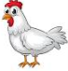1.Does it live on the farm? Yes, it does.

2. Can it fly? No, it can’t.

3. Has it got two wings and a beak? Yes, it has.

4. Does it eat grass? No, it doesn’t.

5. Is it brown? No, it isn’t.

6. Is it a hen? Yes, it is.

1. **Fill in. /** Oglej si Benovo družinsko drevo. Dopolni povedi. **\_\_/8**



<http://youronlinenglishclass.com.pt>

|  |  |  |  |  |
| --- | --- | --- | --- | --- |
| 1. | Ben’s sister is Linda . |  | 5. | Ben’s aunt is Susan. |
| 2. | Ben’s grandma is Mary Smith . |  | 6. | Robert's cousin is Sarah. |
| 3. | Ben’s cousins are Timothy, Sarah and Robert. |  | 7. | Susan's brother is John. |
| 4. | Ben’s dad is John Smith . |  | 8. | Peter's son is John . |

1. **Razvrsti besede v pravilni vrstni red. Ne pozabi na ločila – (? . ) \_\_\_/5**
2. animals are Which poisonous

Which animals are poisonus?

1. live bears the forest in Do

Do bears live in the forest?

1. foxes Do animals eat other

Do foxes eat other animals?

1. a sharp beak, She’s got and wings two short legs

She’s got a sharp beak, two short legs and wings.

1. very Some are frogs poisonous

Some frogs are very poisonus.

1. **BRALNO RAZUMEVANJE – Odgovori na vprašanja. \_\_\_/5**

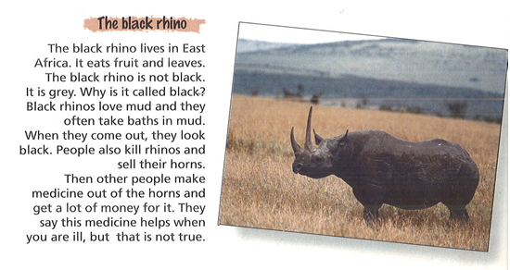

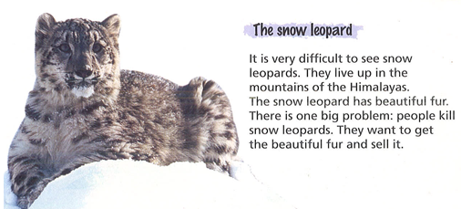

1. Where does the black rhino live? It lives in East Africa.
2. What does the black rhino eat? It eats fruit and leaves.
3. What do people do with their horns? They sell them.
4. Where do the snow leopards live? They live in the mountains of the Himalayas.
5. Why do people kill the snow leopard? They want to get the beautiful fur and sell it.