Ime in priimek: \_\_\_\_\_\_\_\_\_\_\_\_\_\_\_\_\_\_\_\_\_ Točke: \_\_\_\_\_/53

Razred:\_\_\_\_\_\_\_\_\_\_\_\_ Odstotki: \_\_\_\_\_\_\_\_\_

Datum: \_\_\_\_\_\_\_\_\_\_\_

**PREVERJANJE 2 5. RAZRED**

1. **SLUŠNA NALOGA**

[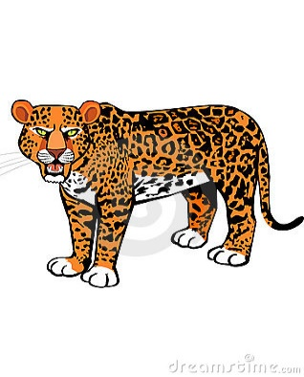](http://www.google.si/url?sa=i&rct=j&q=&esrc=s&source=images&cd=&cad=rja&uact=8&ved=0ahUKEwiO6pH3o6LLAhVC2hoKHWe-CToQjRwIBw&url=http://www.dreamstime.com/stock-illustration-hungry-leopard-cartoon-vector-illustration-image44389224&bvm=bv.115339255,d.ZWU&psig=AFQjCNENwwUmC7wKJ05GU4zMbHcDB0DtBg&ust=1457017627192483)

**Poslušaj posnetke in označi stavke z YES ali NO. \_\_\_/7**

[](http://www.google.si/url?sa=i&rct=j&q=&esrc=s&source=images&cd=&cad=rja&uact=8&ved=0ahUKEwjn-YvqpKLLAhXGChoKHU3zB0AQjRwIBw&url=http://kidungdraw.cf/cartoon/cartoon-lion-pictures.html&psig=AFQjCNH8DadV6rtJE17TwAqiUDXQuNOv3w&ust=1457017910063911)

|  |  |
| --- | --- |
| 1. Leopard is a big cat. |  |
| 1. Leopards can’t swim. |  |
| 1. Leopards live in the bush or in the forest. |  |
| 1. Lions live in groups of 10 to 20 |  |
| 1. Lions eat grass. |  |
| 1. Lions are very lazy. |  |
| 1. They sleep only 5 hours a day. |  |

1. **FOOD \_\_\_/6**

|  |  |  |  |  |  |
| --- | --- | --- | --- | --- | --- |
| **name** | √ | **x** | **name** | **√** | **x** |
| **Jane** |  | [popcorn](http://esladventures.files.wordpress.com/2007/10/popcorn.gif) | **Paula** |  | [1](http://images.google.si/imgres?imgurl=http://www.l-m.si/upload/fotogalerija/v/1.1.1.5-alp-mleko-3.5.-0.5.jpg&imgrefurl=http://www.l-m.si/medijsko_sredisce/izdelki&h=400&w=400&sz=39&hl=sl&start=3&tbnid=6tDE9GYDxguPLM:&tbnh=124&tbnw=124&prev=/images?q=mleko&gbv=2&hl=sl) |
| **Amanda** |  |  | **Simon** | [milka_winterdreams3](http://images.google.si/imgres?imgurl=http://www.alertmedia.pl/img/pressroom/kraft_swieta/milka_winterdreams3.jpg&imgrefurl=http://matejaurajnar.blogspot.com/2007_12_01_archive.html&h=827&w=1713&sz=286&hl=sl&start=89&tbnid=r1b5fc3VthMs7M:&tbnh=72&tbnw=150&prev=/images?q=%C4%8Dokolada&start=72&gbv=2&ndsp=18&hl=sl&sa=N) | [jalbocna-baterija-2](http://images.google.si/imgres?imgurl=http://junior.si/images/uploads/eksperimentalnica/jalbocna-baterija-2.jpg&imgrefurl=http://junior.si/eksperimentalnica/arhiv/jabolchna_baterija/&h=230&w=230&sz=29&hl=sl&start=9&tbnid=maCWx_sa-IAN_M:&tbnh=108&tbnw=108&prev=/images?q=jabolko&gbv=2&hl=sl) |

1. **Odgovori na naslednja vprašanja s kratkimi odgovori.**

Does Jane like popcorn? \_\_\_\_\_\_\_\_\_\_\_\_\_\_\_\_\_

Does Paula like lemonade? \_\_\_\_\_\_\_\_\_\_\_\_\_\_\_

Does Amanda like fish? \_\_\_\_\_\_\_\_\_\_\_\_\_\_\_

Does Simon like apples? \_\_\_\_\_\_\_\_\_\_\_\_\_\_\_\_\_\_

1. **Napiši stavke za ostalo hrano, ki še ni bila omenjena v zgornjih vprašanjih in uporabi *likes* in *doesn’t like*.**

Jane \_\_\_\_\_\_\_\_\_\_\_\_\_\_\_\_\_\_\_\_\_\_\_\_\_\_\_\_\_\_.

Paula \_\_\_\_\_\_\_\_\_\_\_\_\_\_\_\_\_\_\_\_\_\_\_\_\_\_\_\_\_\_.

Amanda \_\_\_\_\_\_\_\_\_\_\_\_\_\_\_\_\_\_\_\_\_\_\_\_\_\_\_\_.

Simon\_\_\_\_\_\_\_\_\_\_\_\_\_\_\_\_\_\_\_\_\_\_\_\_\_\_\_\_\_\_

1. **ŠTEVILA DO 100 – Na črte zapiši ustrezne besede za števila do 100. \_\_/10**

|  |  |  |  |
| --- | --- | --- | --- |
| 18 |  | 53 |  |
| 12 |  | 77 |  |
| 34 |  | 100 |  |
| 69 |  | 95 |  |
| 42 |  | 81 |  |

1. **What's the time? Koliko je ura? Na črto s celim stavkom napiši koliko je ura. \_\_\_/5**

**V treh primerih uporabi naslednje fraze:**

**half past o’clock**

1. 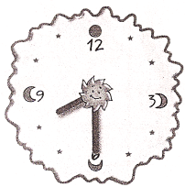 2.  3. 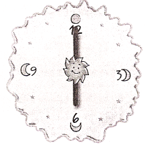 4.  5. 

|  |  |
| --- | --- |
| 1. It’s | 2. |
| 3. | 4. |
| 5. | |

1. **Pobarvaj sliko in opiši žival. \_\_/6**

**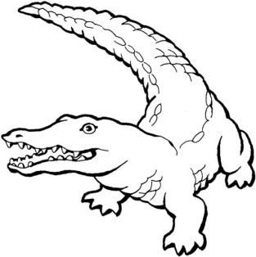 This is a \_\_\_\_\_\_\_\_\_\_\_\_\_\_\_\_\_\_\_\_\_\_\_\_. It is green.**

**It has got \_\_\_\_\_\_\_\_\_\_\_\_\_\_\_\_\_\_\_\_\_\_\_\_\_\_\_\_\_\_\_ and a long \_\_\_\_\_\_\_\_\_\_\_.**

**It eats \_\_\_\_\_\_\_\_\_\_\_\_\_\_\_\_\_\_\_\_\_\_\_\_\_\_\_\_\_\_. It lives in \_\_\_\_\_\_\_\_\_\_\_\_\_\_\_\_\_.**

**It can \_\_\_\_\_\_\_\_\_\_\_\_\_\_\_\_\_\_\_\_\_\_\_\_\_\_\_.**

1. **Tvori vprašanja o spodnji živali. Uporabi besede v okvirčku. Nekaj besed je preveč.**

Potem na vprašanja odgovori. **\_\_\_/6**

run live has two wings have grass fly brown worms

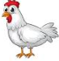1.Does it \_\_\_\_\_\_\_\_\_\_\_\_\_\_ on the farm? Yes, \_\_\_\_\_\_\_\_\_\_\_\_\_\_\_.

2. Can it \_\_\_\_\_\_\_\_\_\_\_\_\_? No, it \_\_\_\_\_\_\_\_\_\_\_.

3. \_\_\_\_\_\_\_ it got two legs and \_\_\_\_\_\_\_\_\_\_? Yes, it \_\_\_\_\_\_\_\_\_\_\_.

4. Does it eat \_\_\_\_\_\_\_\_\_\_\_\_\_\_\_\_\_\_? No, \_\_\_\_\_\_\_\_\_\_\_\_\_\_\_.

5. Is it \_\_\_\_\_\_\_\_\_\_\_\_? No, it \_\_\_\_\_\_\_\_\_\_\_\_.

6. Is it a hen? Yes, \_\_\_\_\_\_\_\_\_\_\_\_\_.

1. **Fill in. /** Oglej si Benovo družinsko drevo. Dopolni povedi. **\_\_/8**



<http://youronlinenglishclass.com.pt>

|  |  |  |  |  |
| --- | --- | --- | --- | --- |
| 1. | Ben’s sister is \_\_\_\_\_\_\_\_\_\_\_\_ . |  | 5. | Ben’s \_\_\_\_\_\_\_\_\_\_\_\_\_ is Susan. |
| 2. | Ben’s grandma is \_\_\_\_\_\_\_\_\_\_\_\_ . |  | 6. | Robert's \_\_\_\_\_\_\_\_\_\_ is Sarah. |
| 3. | Ben’s cousins are \_\_\_\_\_\_\_\_\_\_\_\_  \_\_\_\_\_\_\_\_\_\_\_\_\_\_\_\_\_\_\_\_\_\_\_\_ . |  | 7. | Susan's \_\_\_\_\_\_\_\_\_\_\_\_\_ is John. |
| 4. | Ben’s dad is \_\_\_\_\_\_\_\_\_\_\_\_\_\_\_ . |  | 8. | Peter's \_\_\_\_\_\_\_\_\_\_\_\_\_\_ is John . |

1. **Razvrsti besede v pravilni vrstni red. Ne pozabi na ločila – (? . ) \_\_\_/5**
2. animals are Which poisonous

\_\_\_\_\_\_\_\_\_\_\_\_\_\_\_\_\_\_\_\_\_\_\_\_\_\_\_\_\_\_\_\_\_\_\_\_\_\_\_\_\_\_\_\_\_\_\_\_\_\_\_\_\_\_\_\_\_

1. live bears the forest in Do

\_\_\_\_\_\_\_\_\_\_\_\_\_\_\_\_\_\_\_\_\_\_\_\_\_\_\_\_\_\_\_\_\_\_\_\_\_\_\_\_\_\_\_\_\_\_\_\_\_\_\_\_\_\_\_\_\_

1. foxes Do animals eat other

\_\_\_\_\_\_\_\_\_\_\_\_\_\_\_\_\_\_\_\_\_\_\_\_\_\_\_\_\_\_\_\_\_\_\_\_\_\_\_\_\_\_\_\_\_\_\_\_\_\_\_\_\_\_\_\_

1. a sharp beak, She’s got and wings two short legs

\_\_\_\_\_\_\_\_\_\_\_\_\_\_\_\_\_\_\_\_\_\_\_\_\_\_\_\_\_\_\_\_\_\_\_\_\_\_\_\_\_\_\_\_\_\_\_\_\_\_\_\_\_\_\_\_\_\_\_\_\_\_\_

1. very Some are frogs poisonous

\_\_\_\_\_\_\_\_\_\_\_\_\_\_\_\_\_\_\_\_\_\_\_\_\_\_\_\_\_\_\_\_\_\_\_\_\_\_\_\_\_\_\_\_\_\_\_\_\_\_\_\_\_\_\_\_\_\_\_\_\_\_\_\_\_\_\_\_\_\_\_\_\_\_\_

1. **BRALNO RAZUMEVANJE – Odgovori na vprašanja. \_\_\_/5**

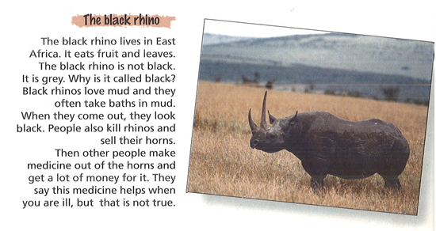

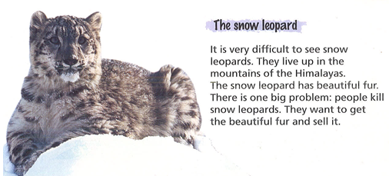

1. Where does the black rhino live? \_\_\_\_\_\_\_\_\_\_\_\_\_\_\_\_\_\_\_\_\_\_\_\_\_\_\_\_\_\_\_\_\_\_\_\_\_\_\_\_\_\_\_\_\_\_
2. What does the black rhino eat? \_\_\_\_\_\_\_\_\_\_\_\_\_\_\_\_\_\_\_\_\_\_\_\_\_\_\_\_\_\_\_\_\_\_\_\_\_\_\_\_\_\_\_\_\_\_\_
3. What do people do with their horns? \_\_\_\_\_\_\_\_\_\_\_\_\_\_\_\_\_\_\_\_\_\_\_\_\_\_\_\_\_\_\_\_\_\_\_\_\_\_\_\_\_\_\_
4. Where do the snow leopards live? \_\_\_\_\_\_\_\_\_\_\_\_\_\_\_\_\_\_\_\_\_\_\_\_\_\_\_\_\_\_\_\_\_\_\_\_\_\_\_\_\_\_\_\_\_
5. Why do people kill the snow leopard? \_\_\_\_\_\_\_\_\_\_\_\_\_\_\_\_\_\_\_\_\_\_\_\_\_\_\_\_\_\_\_\_\_\_\_\_\_\_\_\_\_\_

\_\_\_\_\_\_\_\_\_\_\_\_\_\_\_\_\_\_\_\_\_\_\_\_\_\_\_\_\_\_\_\_\_\_\_\_\_\_\_\_\_\_\_\_\_\_\_\_\_\_\_\_\_\_\_\_\_\_\_\_\_\_\_\_\_\_\_\_\_\_\_\_\_\_\_