WHAT'S THE WEATHER LIKE?
It's sunny. |  | 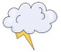
It's rainy. |  | 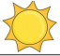
It's foggy. |  | 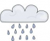
It's snowy. |  | 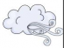
It's cloudy. |  | 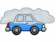
It's windy. |  | 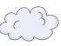
It's partly cloudy. |  | 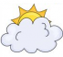
It's stormy. |  | 