A FISH  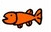 | A FOX  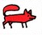 | A TURTLE  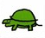
A CHAMELEON  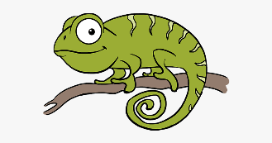 | A FLAMINGO  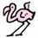 | A GIRAFFE  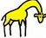
A FLY  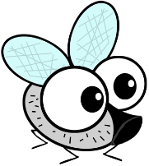 | AN ELEPHANT  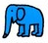 | A SEAL  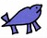
A POLAR BEAR  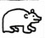 | A DEER  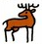
ERIC CARLE: THE MIXED-UP CHAMELEON

