WHAT'S THE WEATHER LIKE?
S… |  | 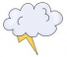
R… |  | 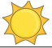
F… |  | 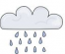
S… |  | 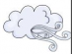
C… |  | 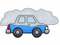
W… |  | 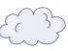
P… C… |  | 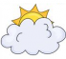
S… |  | 